**Linus Torvalds**

***Genius behind the Linux Kernel and Git.***

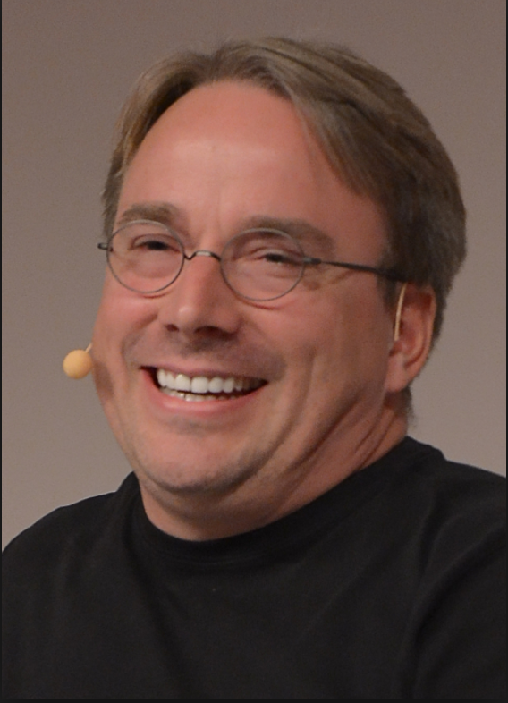Named by Time Magazine as ‘one of the most influential people in the world’, Linus Torvalds is the creative genius behind not only the Linux kernel operating system but also Git, the source code management system which is used by countless developers worldwide. From being listed in The Britannica Guide’s ‘100 Most Influential Inventors of All Time’, to being placed 17th in ‘Time 100: The Most Important People of the Century’, Torvalds is undoubtedly one of the world’s most renowned software engineers. He is accredited with having revolutionised the computer industry all due to Linux – an underdog project which aimed to improve Unix on his Intel 386 computer.

Linus Benedict Torvalds was born in Helsinki, Finland to parents Anna and Nils Torvalds. His love for computers and programming began from a very young age. He studied at the University of Helsinki at which he obtained a master’s degree in Computer Science. During his years at University, Torvalds became obsessed with the idea of creating a free operating system based on both MINIX and UNIX.

In 1991, Torvalds bought himself a computer with an Intel 386 CPU but found himself extremely dissatisfied with the MS-DOS. He much preferred UNIX, which was installed on his university computers. Torvalds believed that this system epitomized what an operating system should be. UNIX is stable and very powerful, however, unfortunately for Torvalds, it was also very expensive. As a result, he resorted to MINIX, a cheaper operating system that is very similar to UNIX. Whilst reading into and studying MINIX, Torvalds began to notice a number of disappointing features. Firstly, although the licensing fee was cheaper than that of UNIX, MINIX was still not free. Secondly, some, but not all, of the source code was available to the public. Finally, the biggest deficit of it was terminal emulation.

It was these drawbacks plus many more which inspired Linus Torvalds to build Linux.

After many months of consistent hard work and programming, Linus released his software on the internet. It was accessible to everyone who wanted to download and 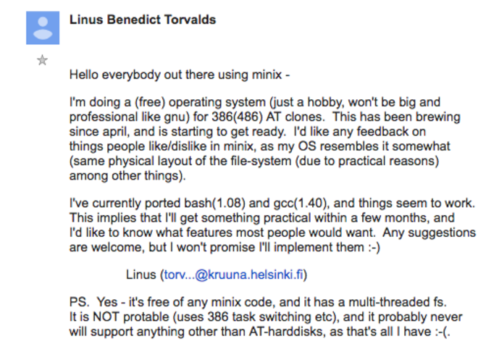use. He also released the source code publicly. This was a very astute decision by Torvalds as it meant that anyone with the proper expertise could modify the software as per their own specifications. As a result, a startling amount of very experienced programmers began to use, refine and develop the Linux Operating System. Over 8,000 developers have contributed to the Linux kernel in the past several years which subsequently has meant that Linux is virtually error free. It rarely crashes, causes bugs or carriers viruses all because the system loopholes have been meticulously combed out by its devoted programmers. It is for this reason that, even though Linux is more complicated to use than Windows or Mac OS, it is far more popular.

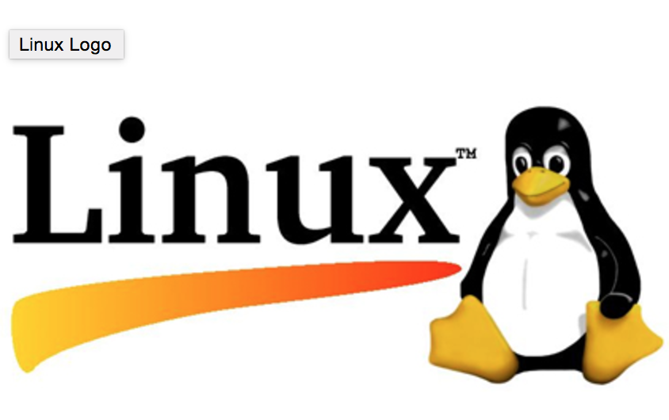Today, Linux is one of the most important pieces of computer software in the world. It is an open source, free operating system. It has changed computer programming. It is the chosen commercial operating system by millions of students, businesses and people worldwide for thousands of reasons. Linux allows one to develop and test UNIX software on their PC, including database and X applications. It is robust and complete enough to handle large tasks, as well as distributed computer needs. Linux is used for web serving, networks, databases, scientific computing, graphics, desktop computing and “embedded-systems”. It is used by a wide variety of businesses such as DreamWorks, Amazon, Google, IBM and Oracle. It is used in countless everyday items such as smart phones and TVs, Kindles, drones and thermostats. Companies turn to Linux when they want to build new technology, a prime example being Tesla and their self-driving cars. While it is hard to make exact Linux-related predictions, one can be certain that it is not going anywhere for the foreseeable future. It has been the leading operations system for over a quarter of a century.

In the early years of the Linux Kernel, maintenance and changes to the software were passed around as patches and archived files. In 2002, however, the Linux kernel began to use a proprietary DVCS called BitKeeper. BitKeeper is a software tool for distributed revision control of computer source code. By 2005, the relationship between the Linux community and the company behind the development of BitKeeper broke down. As a result, BitKeeper revoked the tool’s free of charge status. This revision motivated Linus Torvalds and the wider Linux development community to develop their own tool based system. And so, Git was born.

Today Git is used for thousands of projects and has ushered a whole new level of social coding amongst programmers. It was designed specifically for the requirements of Linux. It is evident of the success of this when one looks at the GitHub repository for the Linux Kernel which boasts over 708,174 commits and an infinite number of contributors.

Git has, in recent years, become the world’s biggest collection of open source software. It has enjoyed this level of success due to its speed, simple design, strong support for non-linear development, full distribution and its ability to efficiently handle large projects just like the Linux kernel. It is an invaluable education and business resource. As with Linux, the service is completely free, a fact that contributes greatly to the bright future of this library.

Apart from all this, Git has also provided the software world with some invaluable statistics, facts and figures about how it is developing – an example being the graph published by GitHub that tracks the popularity of various programming languages. Roughly a decade ago, Java was a language primarily used by banks, businesses and other large companies to build private, intricate programs. Now, according to the users of GitHub, Java is the second most popular programming language. This is merely one example of the fascinating insight this open source software can provide us with.

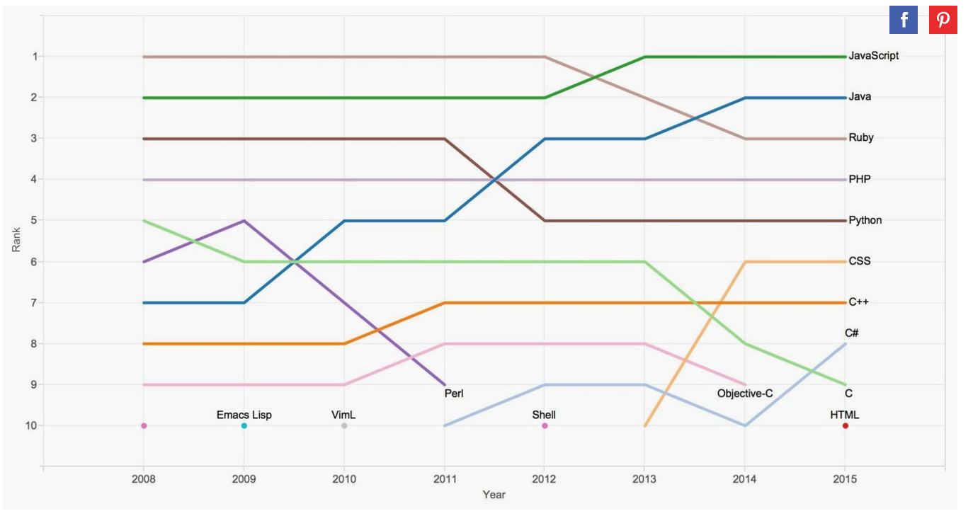

In conclusion, Linus Torvalds is without a doubt one of the most influential software engineers in the modern world today. He has been decorated with countless awards and medals to recognise his additions to the computing industry. In 2012, he was inducted into the Internet Hall of Fame. One finds its almost impossible to imagine the world we live in today without Linux and Git. He is a revolutionary who has changed the world of computing irreversibly and we are forever in his debt because of it. To quote Torvalds himself, “My name is Linus, and I am your God.”.

**References:**

<https://www.britannica.com/biography/Linus-Torvalds>

<https://www.thefamouspeople.com/profiles/linus-torvalds-3972.php>

<https://www.wired.com/2012/03/mr-linux/>

<https://www.wired.com/2016/08/linux-took-web-now-taking-world/>

<https://www.infoworld.com/article/3109204/linux/linux-at-25-how-linux-changed-the-world.html>

<https://www.toptal.com/linux/celebrating-25-years-of-linux>

<https://www.linuxfoundation.org/blog/10-years-of-git-an-interview-with-git-creator-linus-torvalds/>

<https://www.youtube.com/watch?v=4XpnKHJAok8>

<https://github.com/torvalds/linux>

<https://git-scm.com/book/en/v2/Getting-Started-A-Short-History-of-Git>

<https://www.wired.com/2012/11/linus-torvalds-isoc/>

<https://www.wired.com/2015/06/problem-putting-worlds-code-github/>

<https://www.quora.com/What-made-Linus-Torvalds-develop-Linux>

<https://www.brainyquote.com/authors/linus_torvalds>